Experiment 1A

Hosting a static site using xampp
- Download and open the xampp application and click on zip and extract it then click it.
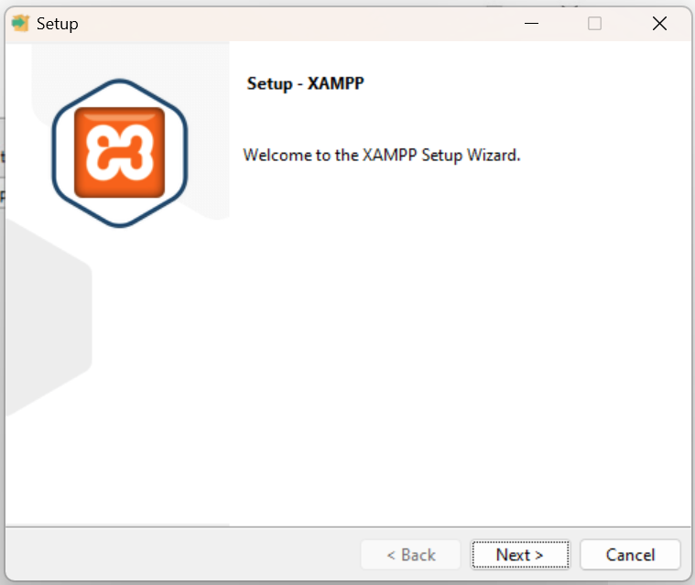
- Then select the c directory.
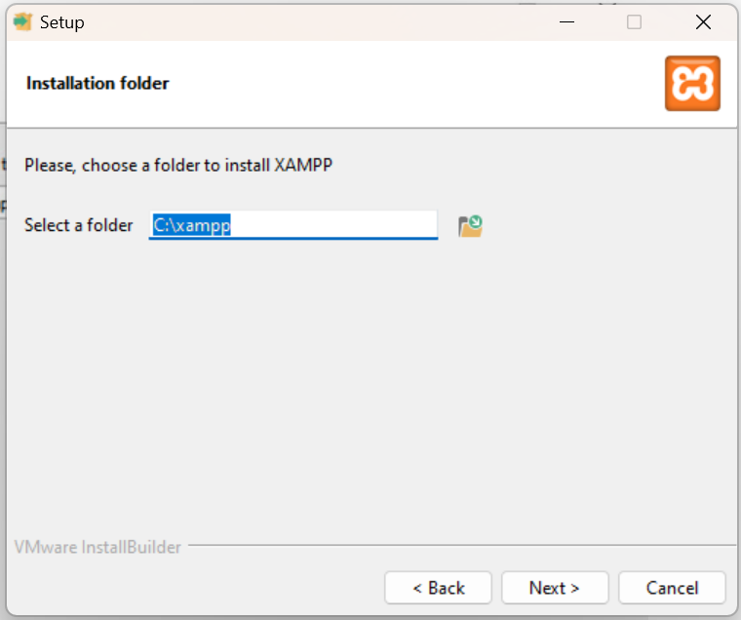
- Then select language as english.
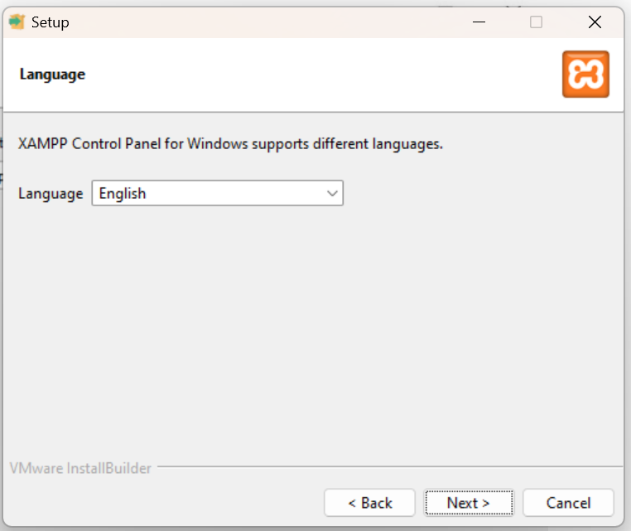
Then install and get started.
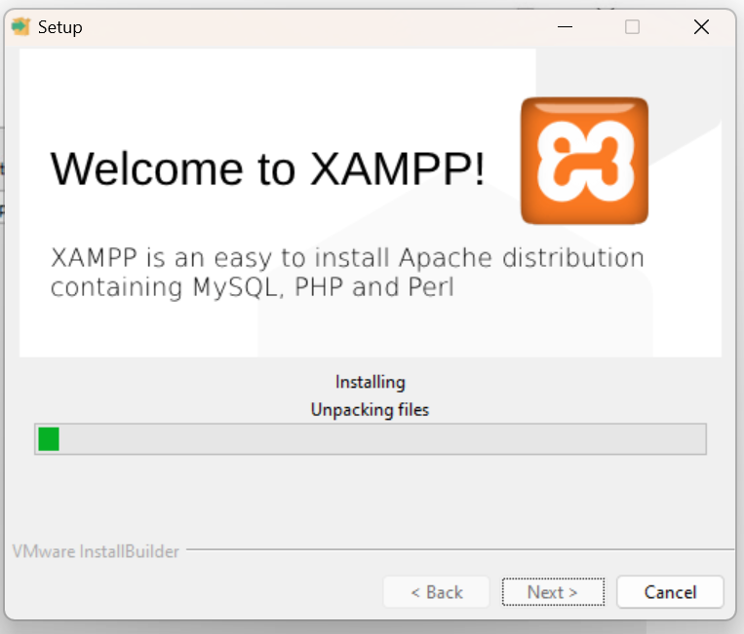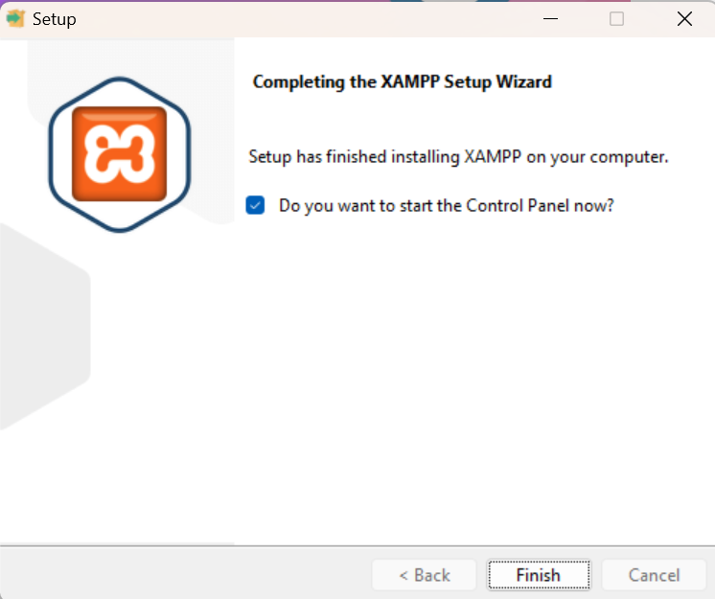

Then the final control panel opens.
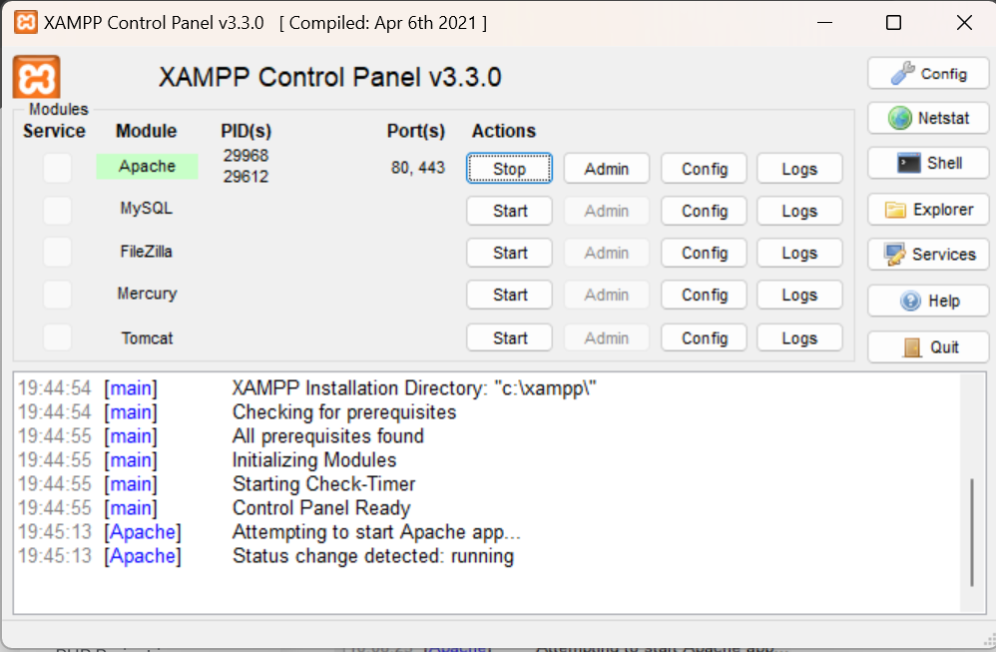
Then I created a file myFile inside htdocs folder and uploaded a sample file.and then opened https:/localhost/myFile/in.php
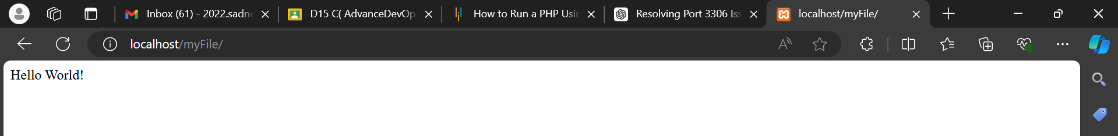

Hosting a static site using S3 bucket:
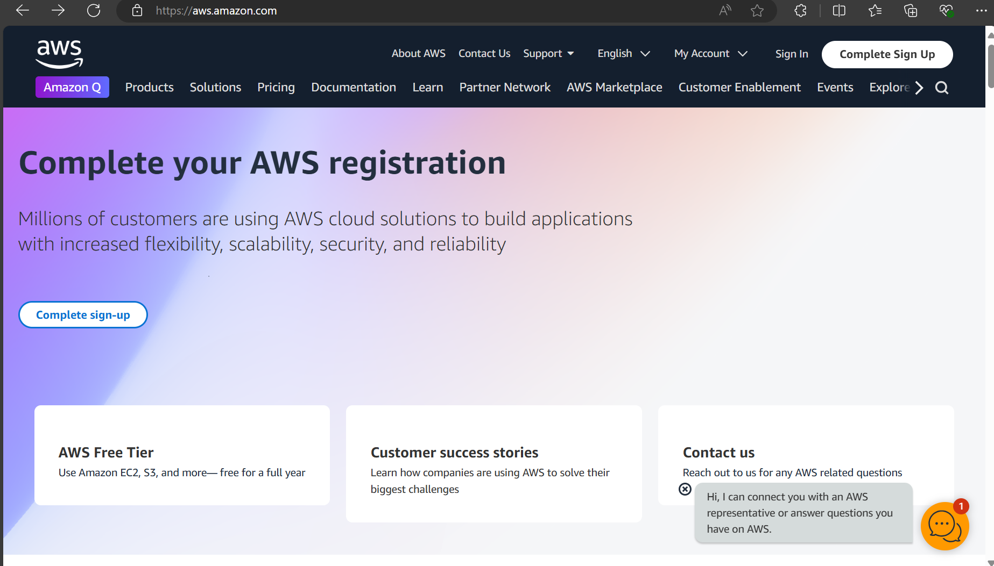
- I clicked on create bucket.
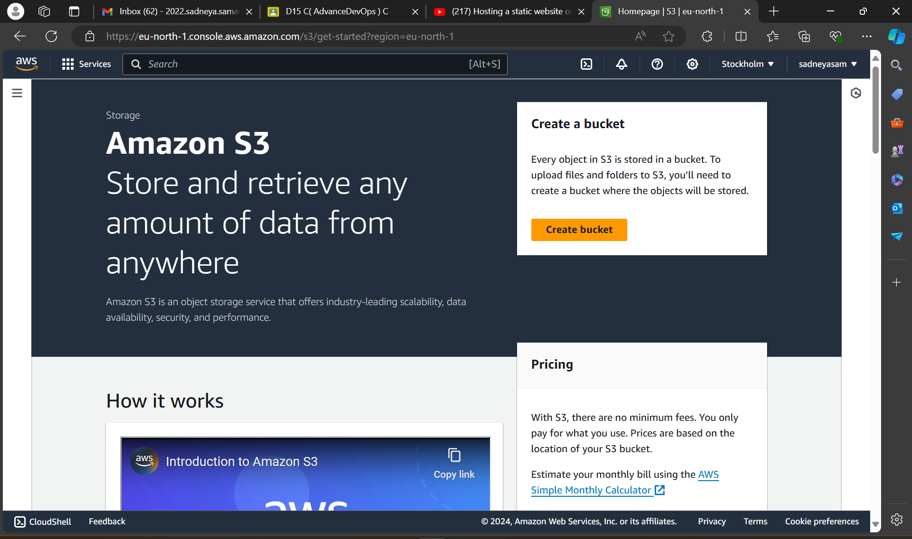
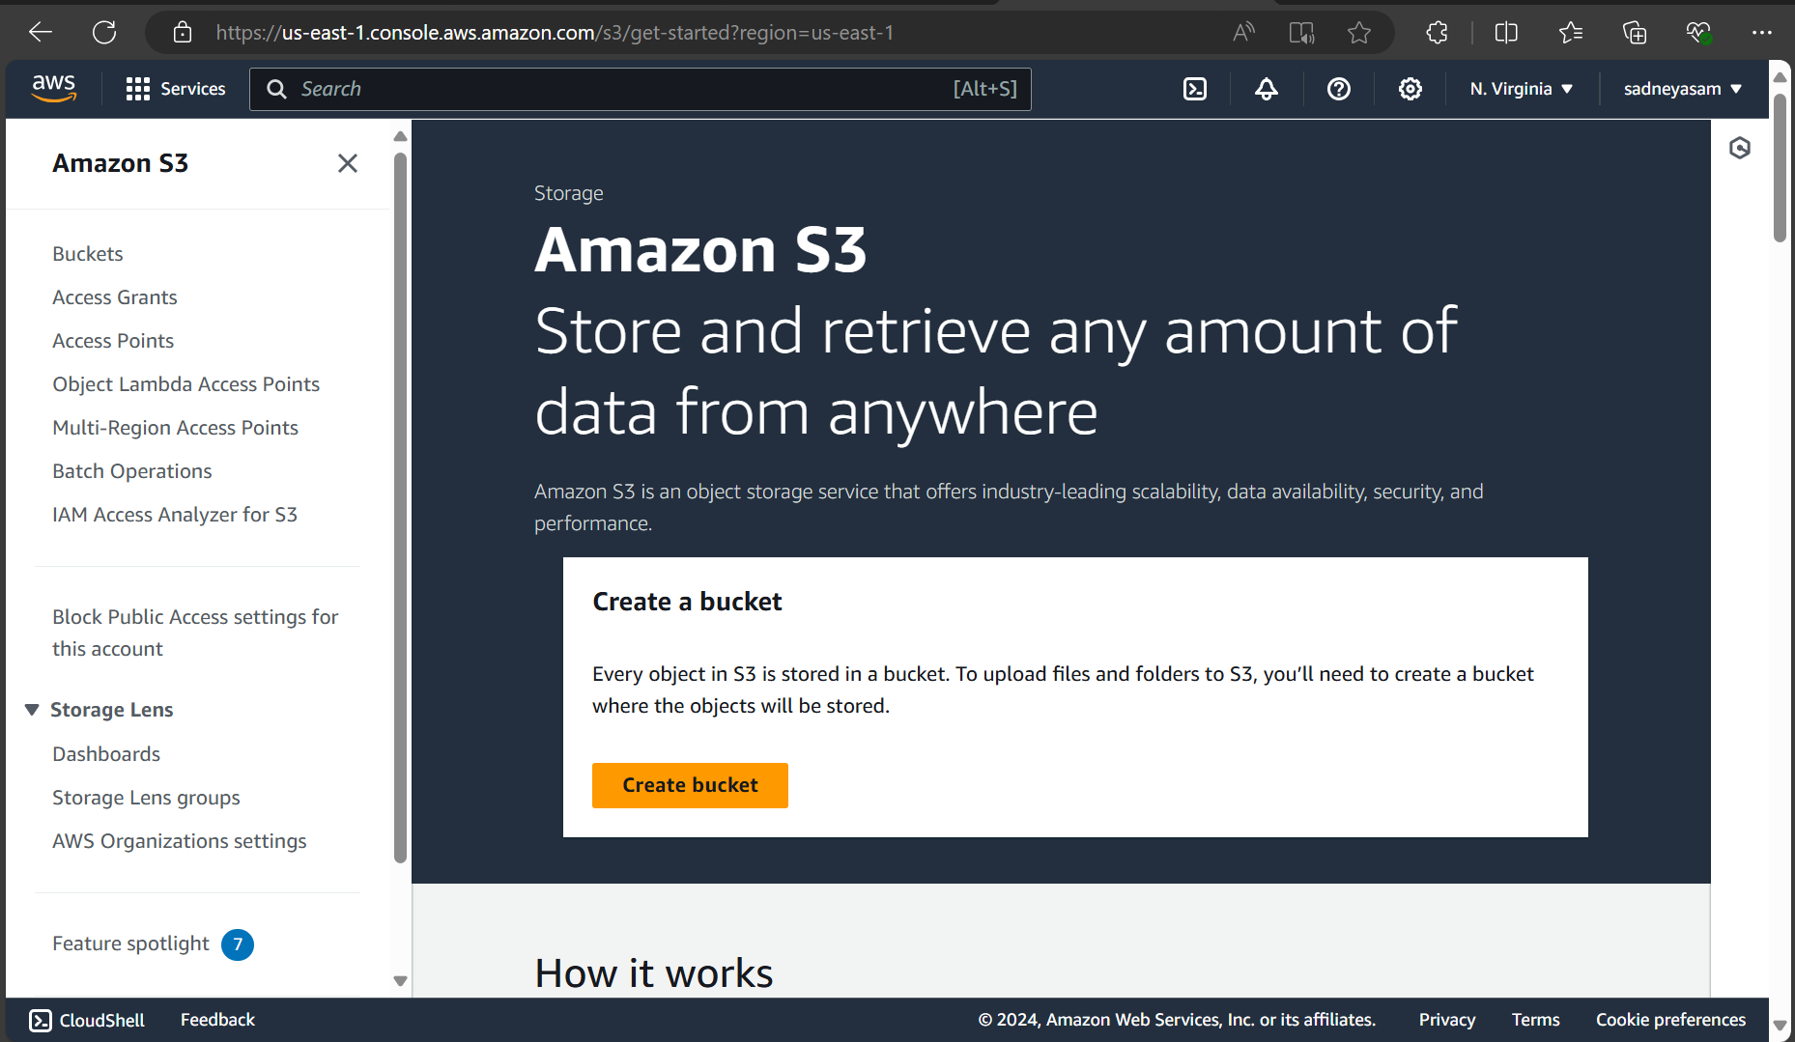
3. Then I created a bucket named www.firstwebsiteofme.com

I clicked on the bucket.

4. Then I also S3 webhosting-bucket policy with this code .I entered in the permission section there is an option edit bucket policy. Where I uploaded the code and saved it.
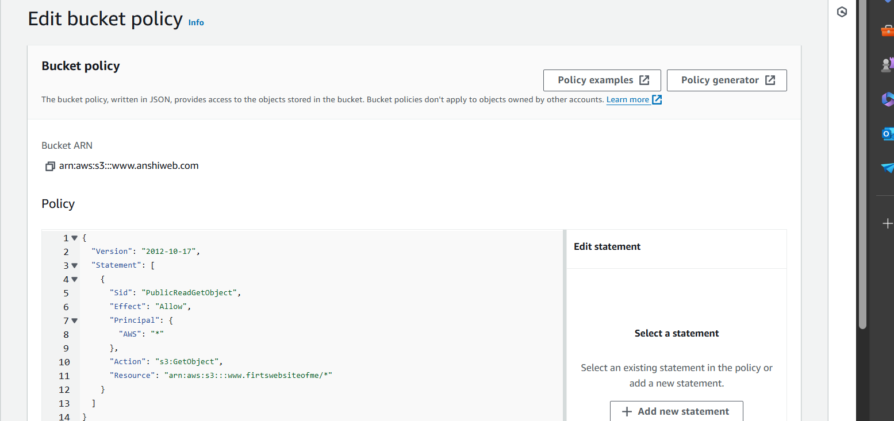
4. Then i clicked on index.html file and opened its properties section.

4. Then I clicked on https://s3.amazonaws.com/www.firstwebsiteofme.com/index.html which given me the final output.

